CERTIFICATE

This is to certify that the project titled **Anomaly Detection in Human Task Performance with Video-Based Contextual Reasoning** submitted by Tuhin Mondal (University Registration No. 304202100900876 of 2021 - 2022),

Swarnanko Saha (University Registration No. 304202100900861 of 2021 - 2022), Ishita Karmakar (University Registration No. 304202100900744 of 2021 - 2022), Aishi Paul (University Registration No. 304202100900735 of 2021 - 2022), and

Arik Das (University Registration No. 304202100900730 of 2021 - 2022) students of the University of Engineering and Management, Kolkata, in partial fulfillment of requirement for the degree of Bachelor of Technology in Computer Science and Engineering (Artificial Intelligence and Machine Learning), is a Bonafide work carried out by them under

the supervision and guidance of Prof. Sramana Muherjee during 8th

Semester of academic session of 2024 - 2025. The content of this report has not been submitted to any other university or institute. I am glad to inform that the work is entirely original and its performance is found to be quite satisfactory.

Signature of Guide

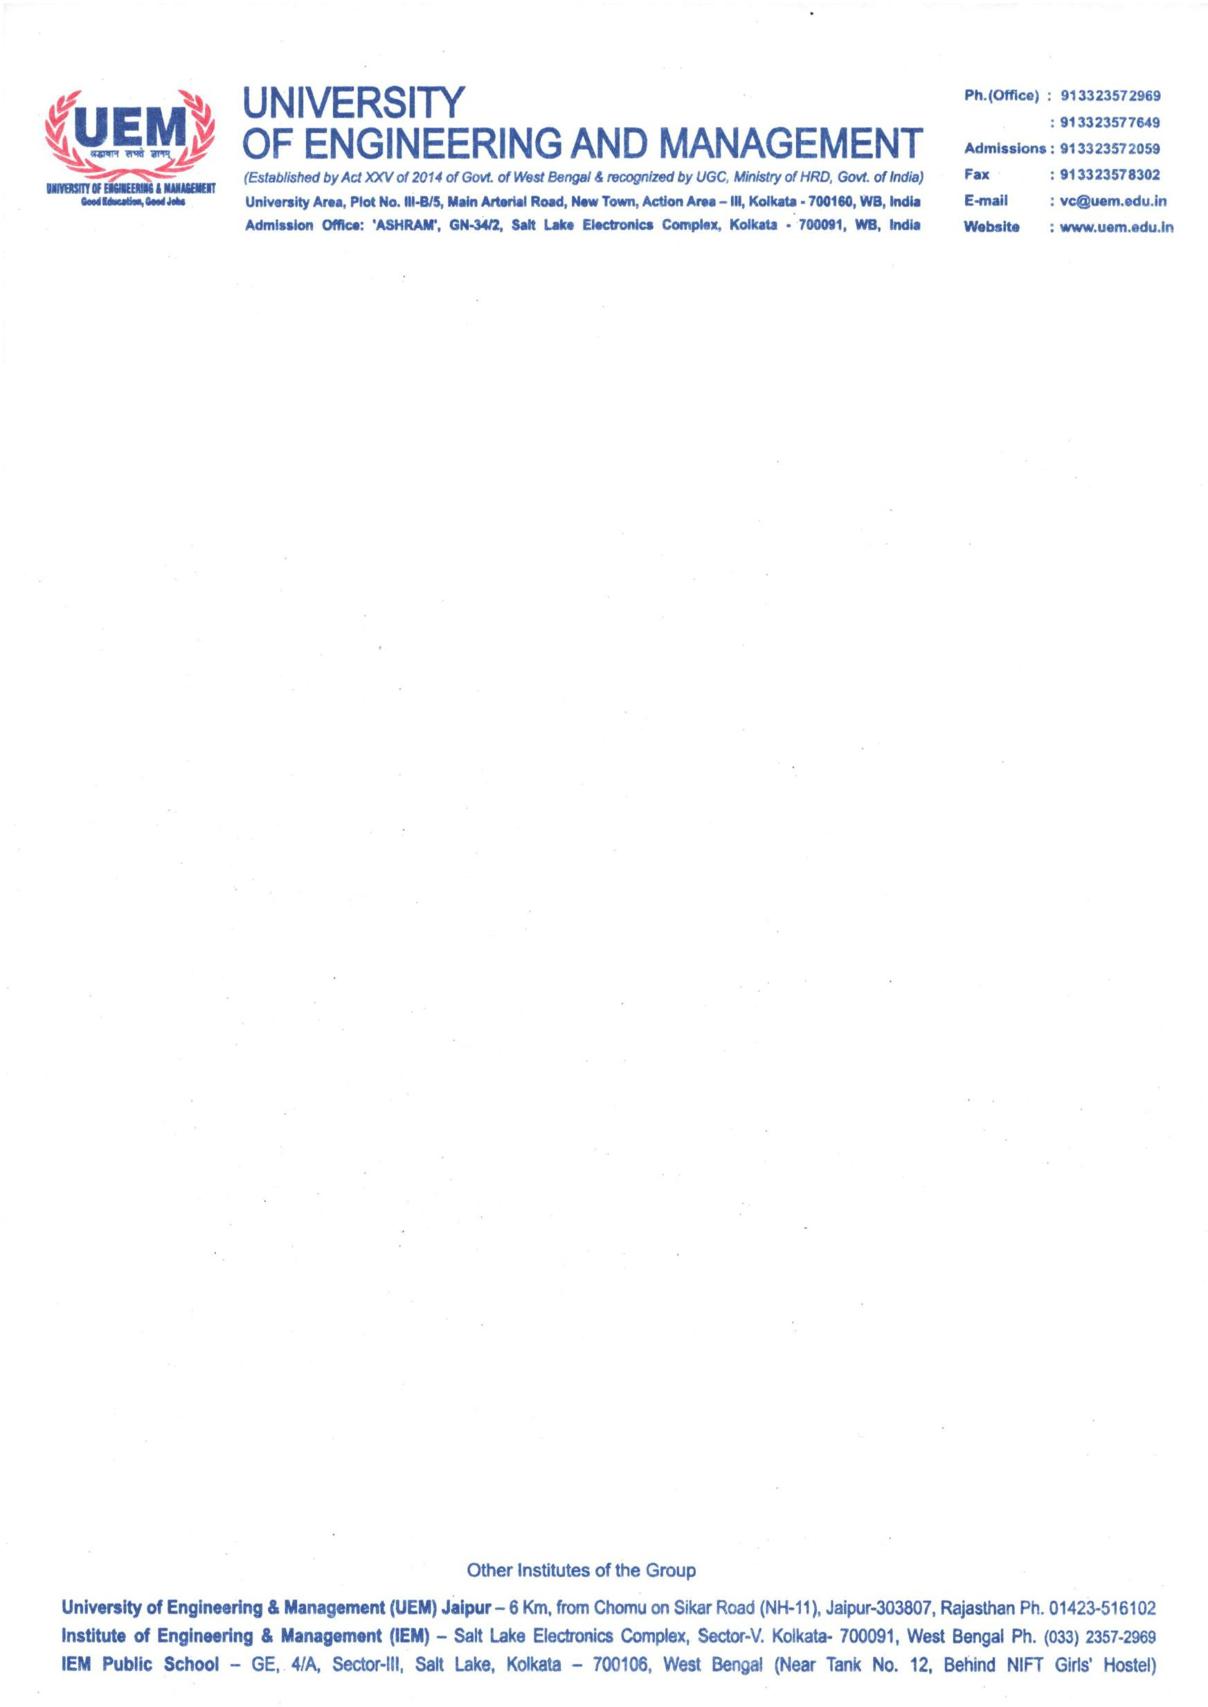

<Name & Designation>

Signature of Head of the Department Department of CSE (AI & ML)